1. Create a class Product with data members: id, name, and description. Create another class LineItem which consist of quantity and Product. Use aggregation to print the lineitem with Product.

package Aggregation;

public class Product {

String id;

String name;

String Description;

public Product(String id, String name, String Desciption) {

this.id = id;

this.name = name;

this.Description = Description;

}

}

package Aggregation;

public class LineItem {

String id;

String name;

String Description;

String quantity;

Product product;

public LineItem(String id, String name, String Description, String quantity, Product product) {

this.id = id;

this.name = name;

this.Description = Description;

this.quantity = quantity;

this.product = product;

}

public static void main(String[] args) {

Product P1 = new Product("1245", "Pro Max", "Healthy");

LineItem L1 = new LineItem("1245", "Pro Max", "Healthy", "250", P1);

System.out.println("ID: " + L1.id);

System.out.println("Name: " + L1.name);

System.out.println("Description: " + L1.Description);

System.out.println("quantity: " + L1.quantity);

}

}

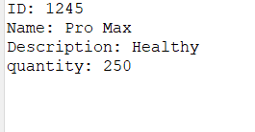

1. Create a class Car with data members: color,carName,regNo. Create another class Employee with empName,empId and Car. Print employee details.

package Aggregation;

public class Car {

String Color;

String CarName;

String RegNo;

Car(String Color,String CarName,String RegNo)

{

this.Color=Color;

this.CarName=CarName;

this.RegNo=RegNo;

}

}

package Aggregation;

public class Employee {

String EmpID;

String EmpName;

Car car;

Employee(String EmpID, String EmpName, Car car) {

this.EmpID = EmpID;

this.EmpName = EmpName;

this.car = car;

}

public static void main(String[] args) {

Car car = new Car("Red", "Polo", "5412");

Employee e = new Employee("452", "Raj", car);

System.out.println("Employee Details");

System.out.println("Employee Name: " + e.EmpName);

System.out.println("Employee ID: " + e.EmpID);

System.out.println("Employee's Car details");

System.out.println("Car Name: " + e.car.CarName);

System.out.println("Car color: " + e.car.Color);

System.out.println("Car Reg No: " + e.car.RegNo);

}

}

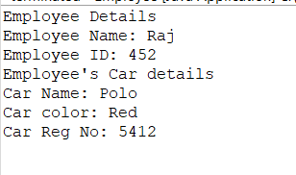

1. Write a Program with following classes
   1. Class 1: Car with data members: color,carName,regNo.
   2. Class 2:Bike with data members: bikeName,regNo.
   3. Class 3: Employee with empName,empId,Car and Bike. Print the employee details

package Aggregation;

public class NewCar {

String Color;

String CarName;

String RegNo;

NewCar(String Color,String CarName,String RegNo)

{

this.Color=Color;

this.CarName=CarName;

this.RegNo=RegNo;

}

}

package Aggregation;

public class NewBike {

String BikeName;

String BRegNo;

NewBike(String BikeName,String BRegNo)

{

this.BikeName=BikeName;

this.BRegNo=BRegNo;

}

}

package Aggregation;

public class NewEmployeeData {

String EmpID;

String EmpName;

NewCar newcar;

NewBike newbike;

NewEmployeeData(String EmpID, String EmpName, NewCar newcar, NewBike newbike) {

this.EmpID = EmpID;

this.EmpName = EmpName;

this.newcar = newcar;

this.newbike = newbike;

}

public static void main(String[] args) {

NewCar C=new NewCar("Red", "XUV", "5412");

NewBike B=new NewBike("Pulsar", "254");

NewEmployeeData NE=new NewEmployeeData("4545","Arun",C,B);

System.out.println("Employee Details");

System.out.println("Employee ID: " + NE.EmpID);

System.out.println("Employee Name: " + NE.EmpName);

System.out.println("Employee Car Details");

System.out.println("Car Color: " + C.Color);

System.out.println("Car Name: " + C.CarName);

System.out.println("Car RegNo: " + C.RegNo);

System.out.println("Employee Bike Details");

System.out.println("Bike Name: " + B.BikeName);

System.out.println("Bike RegNo: " + B.BRegNo);

}}

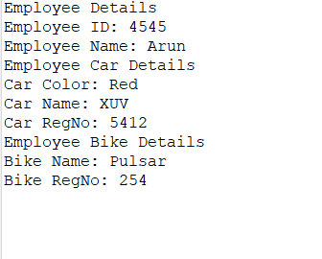

Create a class Author with data members: authorName,age,place. Create another class Book with data members : bookName,price and Author. Print the Book details.

package Aggregation;

public class Author {

String Name;

String Age;

String Place;

public Author(String Name, String Age, String Place) {

this.Name = Name;

this.Age = Age;

this.Place = Place;

}

}

package Aggregation;

public class Book {

String BookName;

String Price;

Author author;

Book(String BookName, String Price, Author author) {

this.BookName = BookName;

this.Price = Price;

this.author = author;

}

public static void main(String args[]) {

Author A = new Author("Sudha", "52", "Delhi");

Book B = new Book("Violet Days", "255", A);

System.out.println("Author Details");

System.out.println("Author Name: " + A.Name);

System.out.println("Author Age: " + A.Age);

System.out.println("Author Place: " + A.Place);

System.out.println("Book Details");

System.out.println("Book Name: " + B.BookName);

System.out.println("Book Price: " + B.Price);

}

}

